**Step1 - Environment setup**

* Java: Oracle OpenJDK version 17.0.1
* Tomcat: 10.1.15
* IDE: Eclipse IDE for Enterprise Java and Web Developers 2023-09

(please make sure that the deployment assembly and build paths of all the above dependencies are properly set).

Please make sure the below dependencies are present for all the four projects (mealService, workoutService, userService, serviceRegistry):

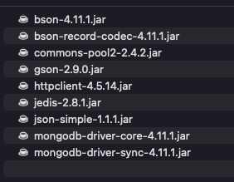

**Step2 - Configure Project**

1. Go to the Open project in Eclipse. Select the folder containing .project as root directory.
2. Go to Project Property->Java build path, use the correct path to import libraries.
3. Go to Window->preferences->server, Add Tomcat v10.1 as your tomcat runtime server.
4. Create a new run configuration, select Tomcat v10.1 localhost as server and modify the working directory to your project root directory.

**Step3 - Launch Project**

Desktop client:

1. First run the following projects in different apache server instances:

* serviceRegistry
* userService
* mealService
* workoutService

1. Go to the project “desktop”
2. Go to src -> src
3. Run Application.java

Web client:

1. First run the following projects in different apache server instances:

* serviceRegistry
* userService
* mealService
* workoutService

1. Open project “web”, and navigate to src->main->webapp

Run the client code from the web project folder and select run on server, and it will open the login page

Credentials for admin user:

xin@gmail.com

password

Credentials for non-admin user:

sid@gmail.com

password